E001: Discovering Robotics

Lesson 8

Activity 1 (Individual)

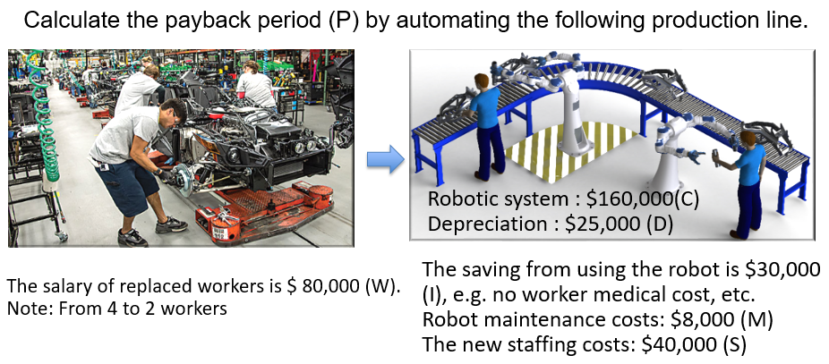

P = C/ (W + I + D – (M + S)
1.839 = 160000/(80000+30000+25000-(8000+40000)
About 2 years

